The Burpham Blog Autumn Term Issue 1 21st September 2022
Welcome back to school and to our new look “Burpham Blog”. We will continue to send these out on a fortnightly basis as a way of capturing and showcasing some of the fabulous learning going on across the school. Important information regarding other aspects of school life will be communicated via Parentmail. Please also continue to use the website and class pages as these will be updated regularly.

We will now be adding any holiday club flyers, nursery/pre-school school job adverts and community information to the website under News & Events/Noticeboard instead of including them on the Blog. There are already some items posted on the ‘Noticeboard’ page, please take a look.

Jo White, Headteacher

Class Pages
It was so lovely to see all the children back in Parrots and to welcome our new children.
We have been very busy getting to know each other and doing all our indoor and outdoor activities. At Forest school, the children did a great job at making a bird from natural materials. In English, our story of the week was 'NOT A BOX' and the children made some great creations from boxes.
In Science, we have been thinking about all the parts of our body. As you can see the feet painting/footprints activity was a huge hit albeit a bit messy😀
It has been a wonderful start!
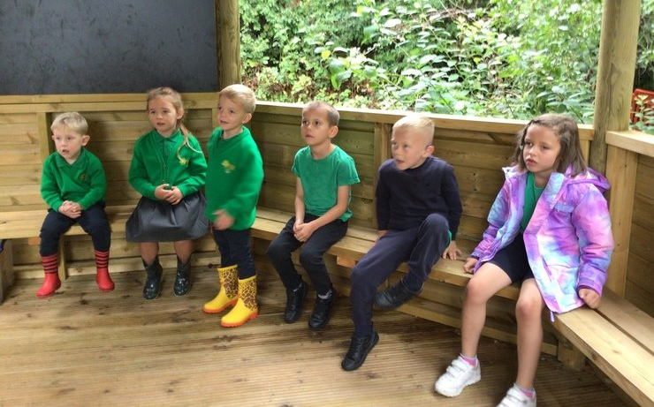
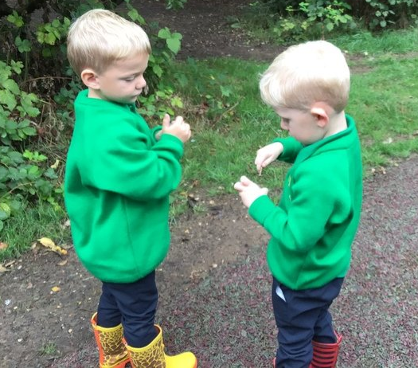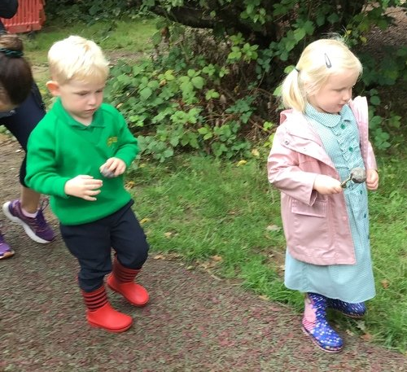
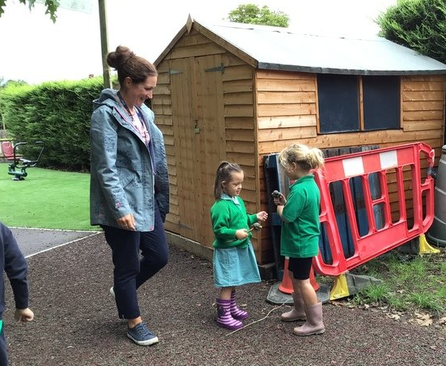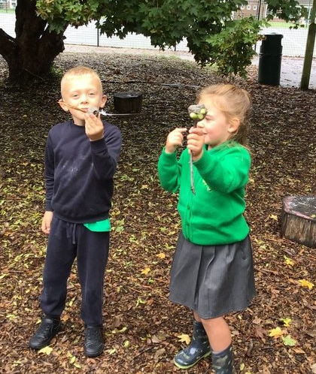
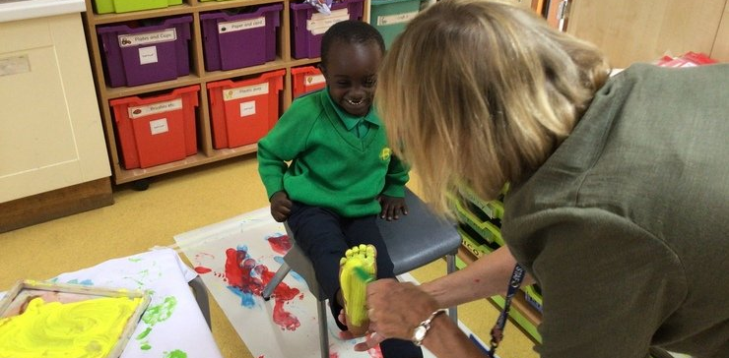

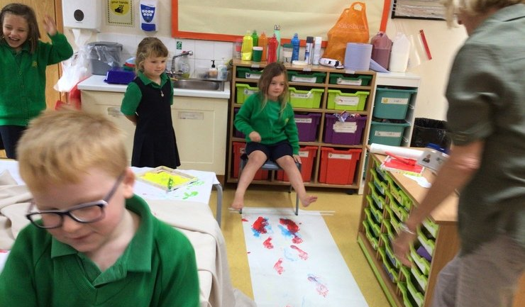

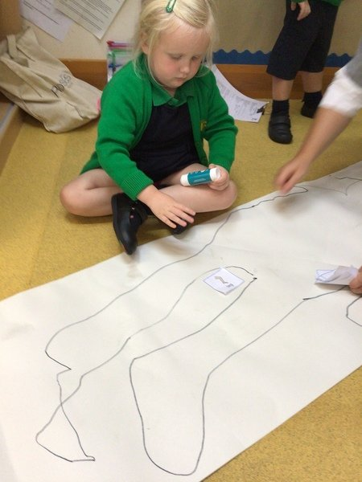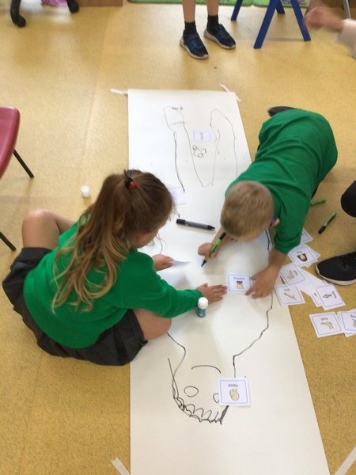

In Year 5, we have been exploring the poem ‘The Jabberwocky’ by Lewis Carroll. In English, we have enjoyed trying to make sense of all the nonsense words, exploring the concept of portmanteau. After discovering the meanings of some words, we had a go at creating our own version of the poem, replacing these nonsense words with our own. In Art, we have been learning about monochrome and grayscale techniques. We have been using various materials including watercolour paint, charcoal and fine liner pens to create different landscapes. This is helping us to prepare for our final project, creating an illustrated version of ‘The Jabberwocky’.
